Air Quality Analysis in Tamil Nadu

# Introduction:

# Air quality is a measure of how clean or polluted the air is. Monitoring air quality is important because polluted air can be bad for our health—and the health of the environment. Air quality is measured with the Air Quality Index, or AQI. The AQI works sort of like a thermometer that runs from 0 to 500 degrees.

# Phase 3 development part 2:

To continue the air quality analysis for Tamil Nadu, we can delve into the key factors affecting air quality in the state and the steps taken for its improvement:

# Key Factors Affecting Air Quality in Tamil Nadu:

Industrial Emissions: Tamil Nadu is home to a significant number of industries, including automobile manufacturing, textile, and petrochemicals. These industries often emit pollutants like particulate matter, sulfur dioxide (SO2), and nitrogen oxides (NOx), which can severely affect air quality.

# Agricultural Activities:

In rural areas, agriculture is a significant contributor to air pollution due to the use of fertilizers, pesticides, and crop residue burning. The latter is a major concern during certain seasons.

# Urbanization:

Rapid urbanization and population growth in cities like Chennai, Coimbatore, and Madurai have led to increased vehicular emissions, construction dust, and solid waste generation, all of which contribute to poor air quality.

# Natural Factors:

Weather conditions, such as temperature inversions, can trap pollutants close to the ground, exacerbating air quality issues. The state's proximity to the Bay of Bengal also influences air quality, with sea breezes sometimes helping disperse pollutants.

# Steps Taken for Air Quality Improvement:

**Regulatory Measures:**

The Tamil Nadu Pollution Control Board (TNPCB) enforces air quality standards and regulations. It has implemented measures to control industrial emissions and monitor compliance.

# Promotion of Green Transport:

Encouraging the use of public transportation, electric vehicles, and cycling can help reduce vehicular emissions. Initiatives such as the Chennai Metro have been introduced to ease traffic congestion.

# Waste Management:

Proper waste management and recycling can reduce the release of air pollutants from landfills and open burning. Tamil Nadu has been promoting the "Swachh Bharat" campaign to address waste issues.

# Crop Residue Management:

To combat crop residue burning, the government can promote alternatives like the use of crop residue for bioenergy or organic manure and provide incentives to farmers for adopting these practices.

# Air Quality Analysis - Phanthamit

# Greenery and Urban Planning:

Increasing green cover in urban areas can help absorb pollutants and improve air quality. Urban planning should prioritize green spaces and efficient land use.

# Air Quality Monitoring:

Expanding and improving air quality monitoring networks across the state is essential for accurate data collection and timely action against pollution sources.

# Public Awareness:

Awareness campaigns to educate the public about the importance of clean air and ways to reduce pollution are crucial. Citizen engagement is a valuable tool in the fight against air pollution.

# Policy Integration:

Coordinating air quality management with other environmental policies, such as water resource management and land-use planning, can lead to more comprehensive solutions.

It's important to note that air quality management is an ongoing process, and the effectiveness of these measures will depend on enforcement, public participation, and continuous assessment of air quality data. Additionally, addressing the unique air quality challenges in different regions of Tamil Nadu, such as coastal and industrial areas, will require tailored strategies. Collaborative efforts involving government, industries, communities, and environmental organizations are essential to ensure a sustainable improvement in air quality throughout the state.

**Program & Output:**

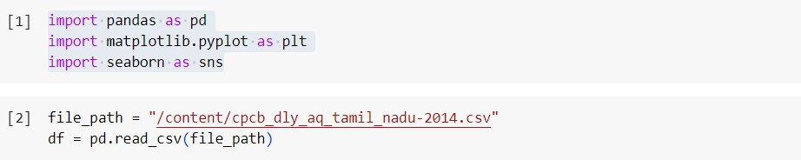

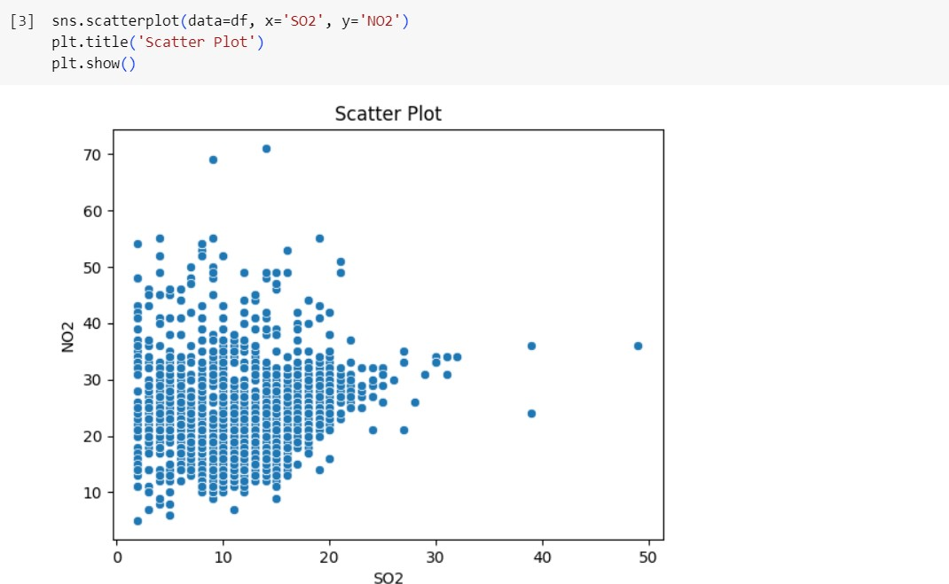

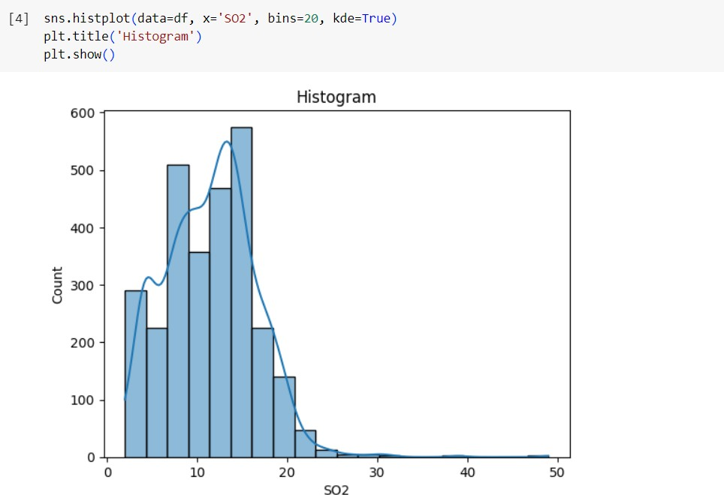

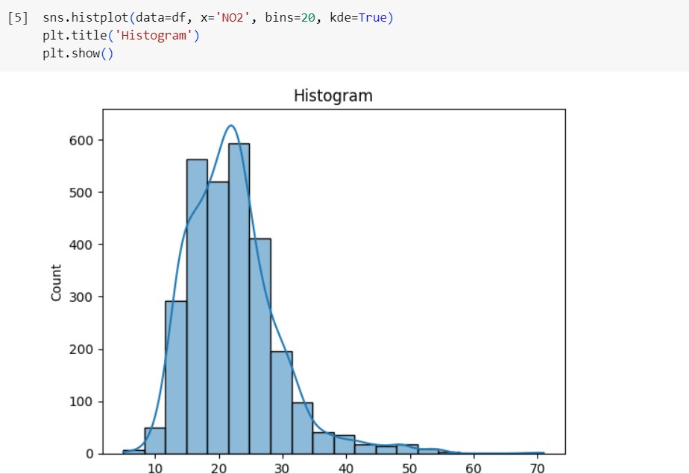

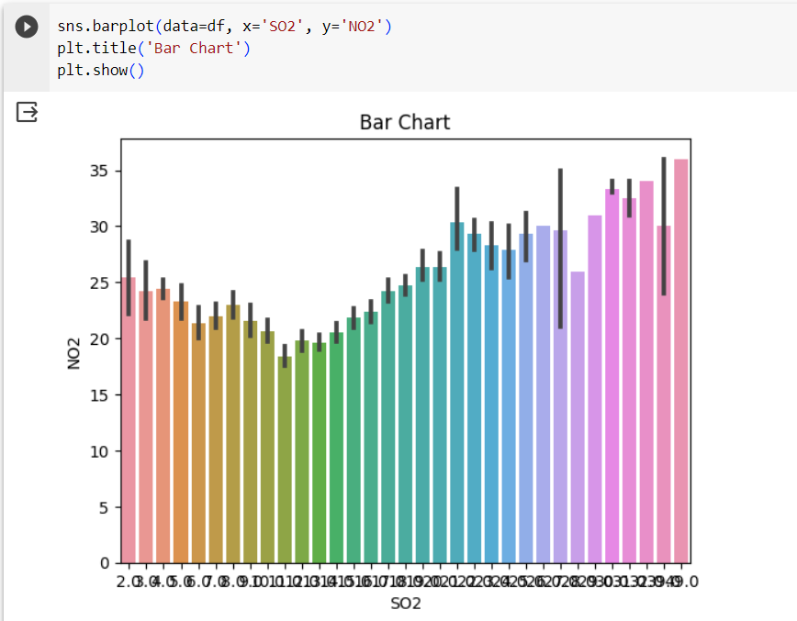

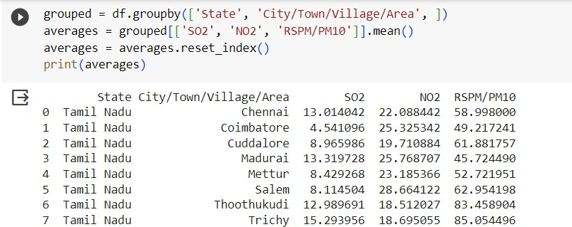

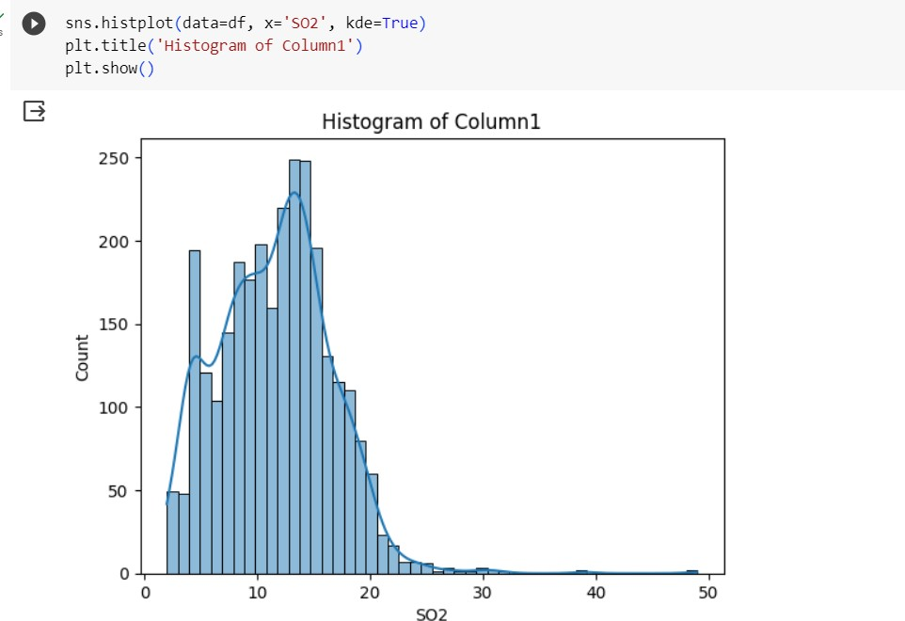

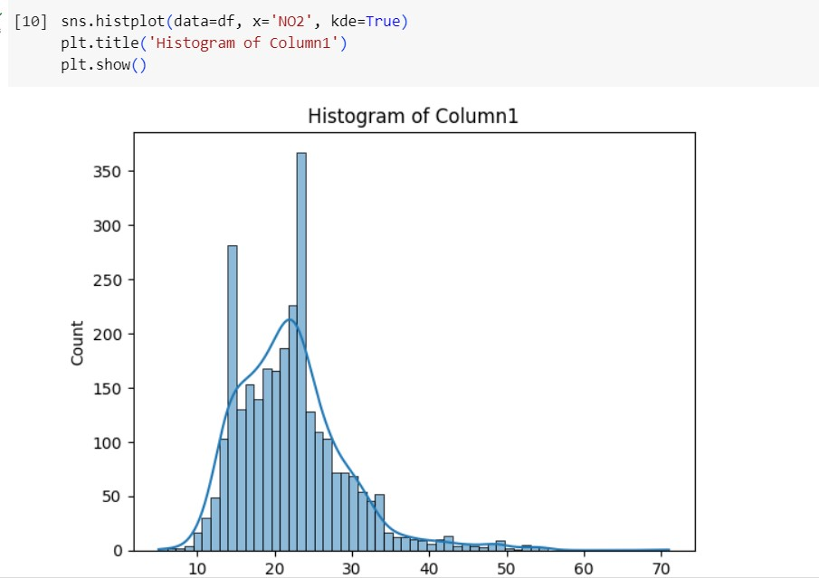

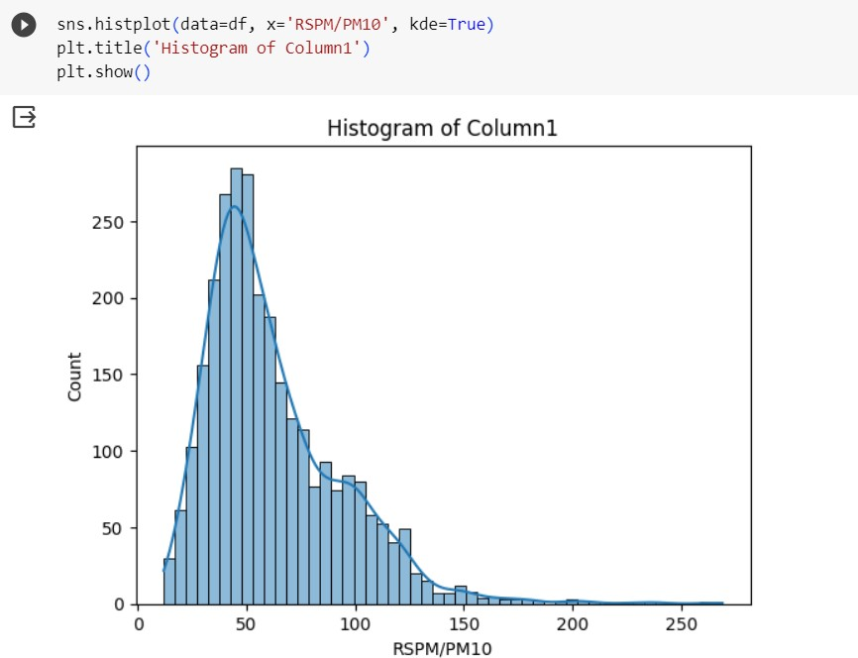

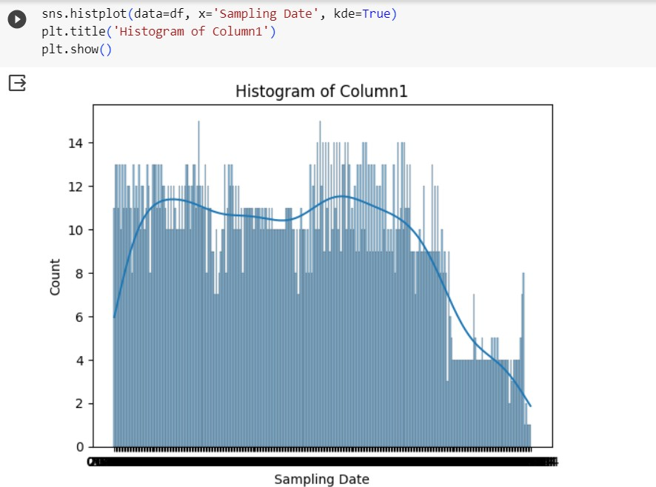

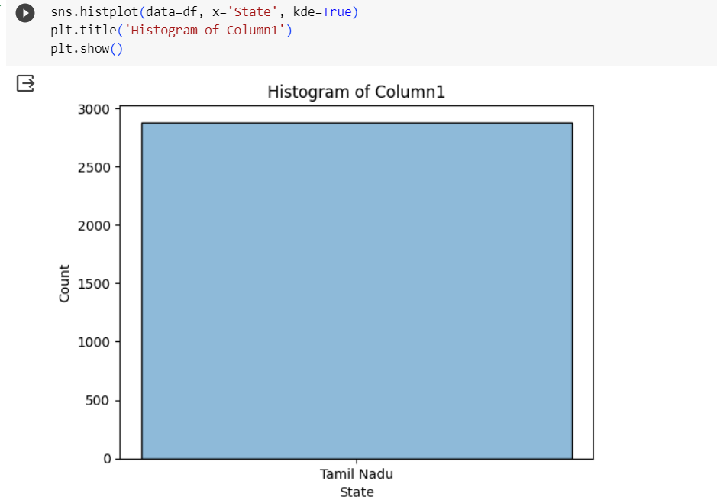

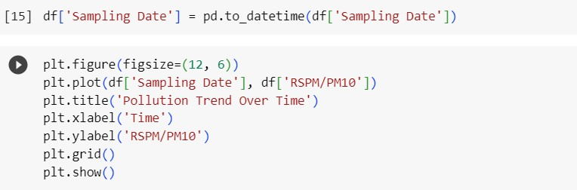

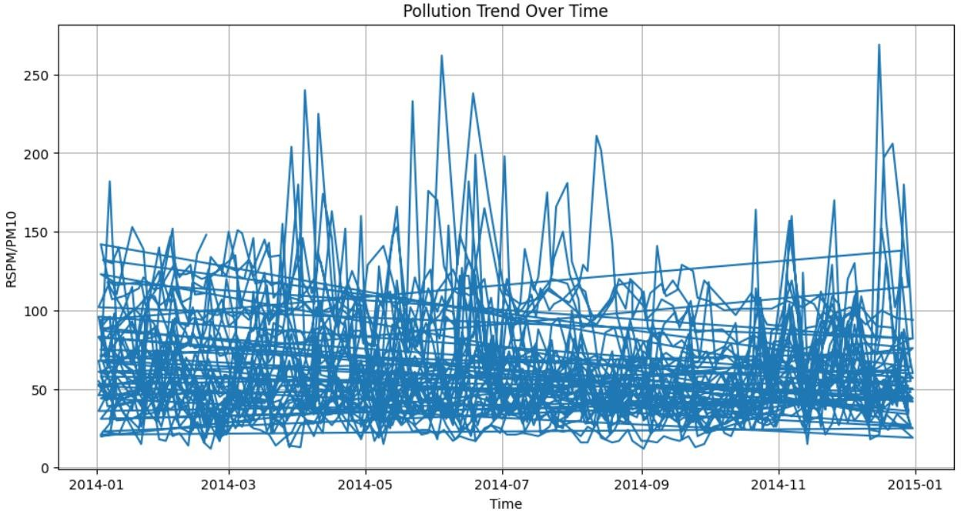

**Conclusion:**

In this we analysis the given sampling data's by comparing the values of RSPM, SO2, NO2 in the given area and also create a graph to represent the given data by using program.